Join Assignment

*Premiere Products and constructco*

* Write the following queries
* Screenshot the **working SQL and output screen**.
* Submit to Blackboard - be sure your name is in the file

Premiere Products Queries

Use your premiere database to solve the next 7 queries

## Inner join Queries to Write

1. Display the customername, and the first and last name of the representative that supports them. Your query is correct when you are around 10 rows.

**select CustomerName, Firstname, Lastname**

**from Rep join Customer**

**on Rep.RepNum = Customer.RepNum**

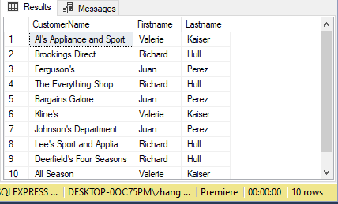

1. Same query as above, but also display the repnum field.

**select CustomerName, Firstname, Lastname, Rep.RepNum**

**from Rep join Customer**

**on Rep.RepNum = Customer.RepNum**

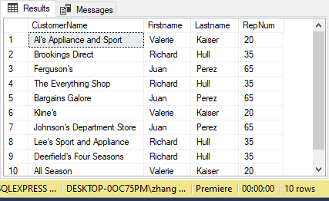

1. Display the order num and the representative that sold that order. You should have 7 rows.

**select FirstName, LastName, OrderNum**

**from Rep join Customer**

**on Rep.RepNum = Customer.RepNum**

**join Orders on Customer.CustomerNum = Orders.CustomerNum**

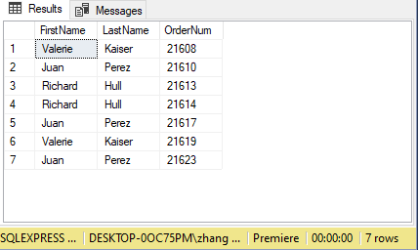

1. Display from part, orderline, and orders the part description, part price, orderdate, customernum, customername, numordered, and the quoted price. You should have around 9 rows.

**select description, Price, Orderdate, Customer.CustomerNum, Customername, Numordered, Quotedprice**

**from Part join OrderLine**

**on Part.PartNum = OrderLine.Partnum**

**join Orders on OrderLine.OrderNum = Orders.OrderNum**

**join Customer on Orders.CustomerNum = Customer.CustomerNum**

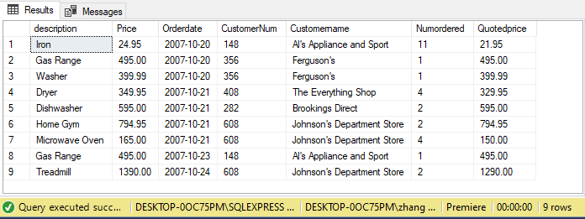

1. List the part descriptions that rep Juan Perez sold. You should have 5 records.

**select Description**

**from Part join OrderLine**

**on Part.PartNum = OrderLine.Partnum**

**join Orders on OrderLine.OrderNum = Orders.OrderNum**

**join Customer on Orders.CustomerNum = Customer.CustomerNum**

**join Rep on Customer.RepNum = Rep.RepNum**

**where LastName = 'Perez'**

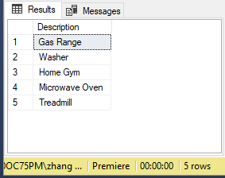

## Outer Join Queries

1. Use the outer join to display the parts that have no orders in the orderline table. You should find 2 products that were never ordered.

**select Description**

**from Part full outer join OrderLine**

**on Part.PartNum = OrderLine.PartNum**

**where NumOrdered is null**

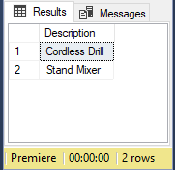

1. Display the customers that have no orders. You should find 5 customers with no orders.

**select CustomerName**

**from Customer full outer join Orders**

**on Customer.CustomerNum = Orders.CustomerNum**

**full outer join OrderLine**

**on Orders.OrderNum = OrderLine.OrderNum**

**where NumOrdered is null**

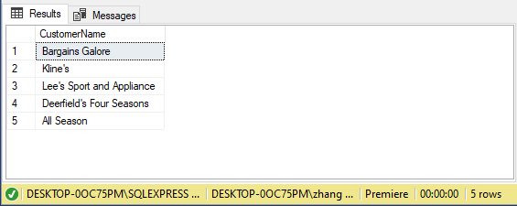

Constructco Queries

Use constructco for the next 3 queries. Constructco is the database you need for your homework assignments. The ER diagram is available in your book in Figure P7.1 on page 323.

## Queries to write

1. Display the employee name, hiredate, job description, and job code. Order by lastname. You should have 18 records.

**select Emp_lname, Emp_Fname, Emp_Hiredate, Job_Description, Employee.Job_Code**

**from EMPLOYEE join JOB**

**on EMPLOYEE.JOB_CODE = JOB.JOB_CODE**

**order by EMP_LNAME**

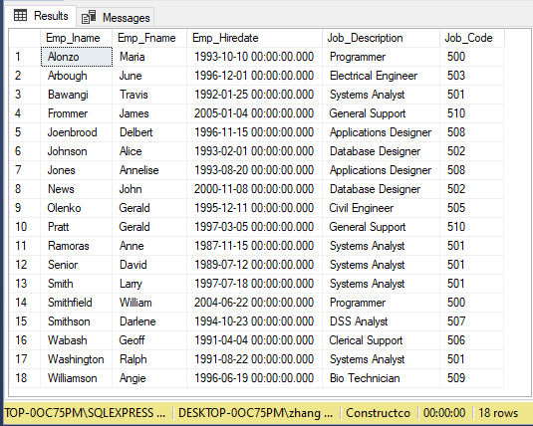

1. Display the project names, the employee name as a fullname, the job description. Limit the output to only the Systems Analyst. Order by project name. You should have 9 rows. For a hint, join project to assignment, not employee.

**select trim(Emp_Fname) + ' ' + trim(Emp_Lname) as FullName, Job_Description, Proj_Name**

**from Project join Assignment**

**on Project.Proj_Num = Assignment.Proj_Num**

**join Employee**

**on Assignment.Emp_Num = Employee.Emp_Num**

**join Job**

**on Employee.Job_Code = Job.Job_Code**

**where Job_Description = 'Systems Analyst'**

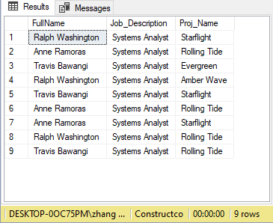

1. We have one job description that does not have an employee assigned. Use an outer join to find this job.

**select Job_Description, Emp_Fname, Emp_Lname**

**from Job full outer join Employee**

**on Job.Job_Code = Employee.Job_Code**

**full outer join Assignment**

**on Employee.Emp_Num = Assignment.Emp_Num**

**where Assign_Job is null**

